Gaus

What is gaus?

Gauss elimination is a way to operate on the values in a matrix, so that it becomes a simpler matrix. You do this by using elementary operations until the result becomes a matrix with a row echelon. This elimination can also be used to solve linear equation problems by entering linear equations using matrices.

Characteristics of the gauss method

1. If a nonzero row is all zero, then the first nonzero number is 1 or the main 1 (in the first row, first column)

2. The zero row is at the bottom

3. The next leading 1 is to the right of the leading 1 of the row above it (in the 2nd row, 2nd column)

4. Below the 1 main must be zero



In this method there are three types of operations that can be used:

1. Change the order of two rows

2. Multiplying rows with non-zero numbers

3. Adding a row with another row

Sample Question:

You are given an SPL of 3 variables

2x + 3y - z = 6

x + 2y - 4z = 8

x + y + 4z = 4

Determine the value of the SPL variables above!

Answer

First step

Transforming the linear equation into an augmented matrix



The 1st row is obtained from 2 + 3y - z = 6

The 2nd line is obtained from x + 2y - 4z = 8

The 3rd line is obtained from x + y + 4z = 4

Second step

Change the first row of the first column (a11) to the number 1



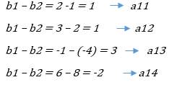

The result of a11, a12, a13 and a14 will be the first row (b1) and the other numbers remain the same.

Third step

Change the 2nd row in the 1st column (a21) to zero and change the 2nd row in the 2nd column (a22) to 1.



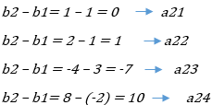

The result of a21, a22, a23 and a24 will be the 2nd row (b2), the values for the other numbers remain the same.

Fourth step

Change the 3rd row of the 1st column (a31) and the 3rd row of the 2nd column (a32) to zeros and the 3rd row of the 3rd column (a33) to 1.



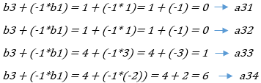

The result of a31, a32, a33 and a34 will be the last row or the 3rd row (b3).

Last step

After completing the characteristics of Gauss elimination and obtaining the row echelon matrix, we can continue by finding the values of the variables x, y and z by substituting them. The method is :



From the matrix above, the new 3-variable SPL is obtained:

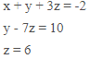

Then we have to substitute the linear equation above to obtain the values of the variables x, y and z. because the value of z is already known, : z = 6

So, the next step is to find the value of the y variable by substituting it into the linear equation with the equation in the 2nd row.

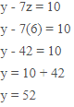

And finally we will find the value of the variable x by substituting it with the linear equation in the first row.

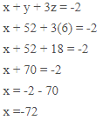

With this, we have obtained the values of the variables above, x = -72, y = 52 and z = 6.

Gauss-SEIDEL Elimination

Definition

Gauss-Seidel elimination is a method that uses a process of iteration until a changing value is obtained

Disclaimer

Iteration techniques are rarely used to solve small systems of linear equations because direct methods such as elimination methods are more efficient than iterative methods.

Example Problem

4x – y – z = 7

4x – 8y + z = -21

-2x + y + 5z = 15

Settlement

- Give initial value

- Change the equation to

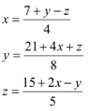

Iteration

> The divisor is the coefficient of the variable of interest when X means a Y means b Z means c With note aX -+ bY +-cZ

>for the result of the equation move the segment so that the result becomes 0>for the result of the equation move the segment so that the result becomes 0

Perform Iteration Process

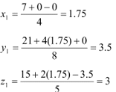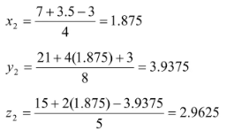

Iteration check

>Use the value of x = 0 to find X through the first equation

>Use the result of x to find the value of Y through the second equation

>Use the result of x y to find the value of z through the third equation

+ continue to iterate until finding the smallest value of each iteration process



Using value calculation

*100% Search until the percentage error is close to 0.00

After doing several iterations, the following table was found

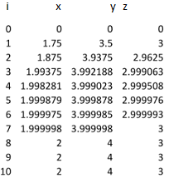

It can be seen that the selilish values of x,y,z in the 7th and 8th iterations are getting smaller so that the percentage becomes 0.00%.

Then x = 2, y = 4, z = 3